🔑 Task 4: PGP/GPG Email Encryption and Signature Simulation

1. ⚙️ Preparation: Generate Key Pairs for Alice and Bob
You need two distinct PGP identities: one for Alice (Sender) and one for Bob (Recipient).

A. Generate Alice's Key Pair (Interactive)
Alice will use her private key for signing.
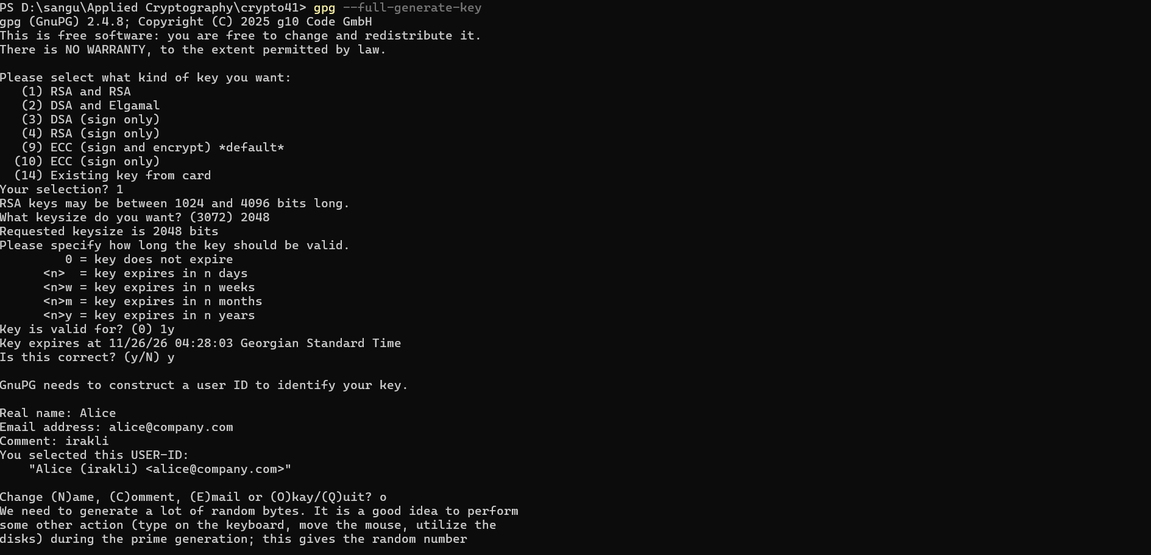
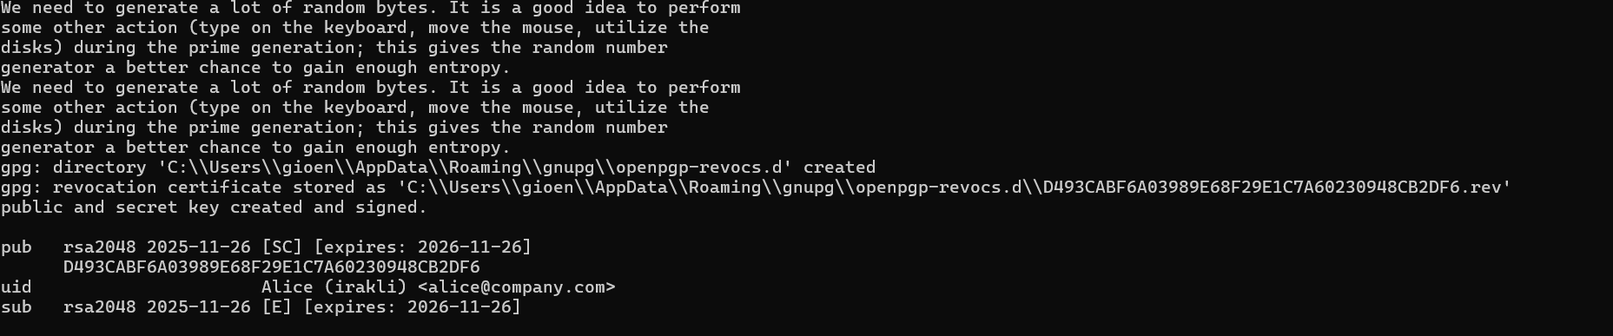

B. Generate Bob's Key Pair
Bob will use his private key to decrypt the message and his public key to be shared so Alice can encrypt the message for him.
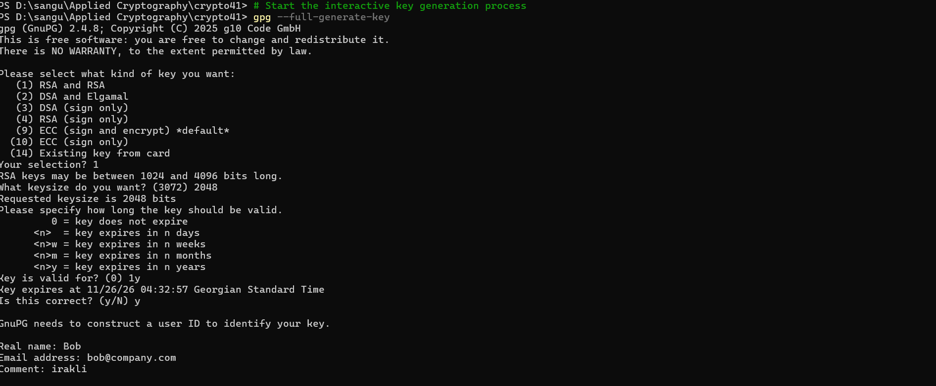
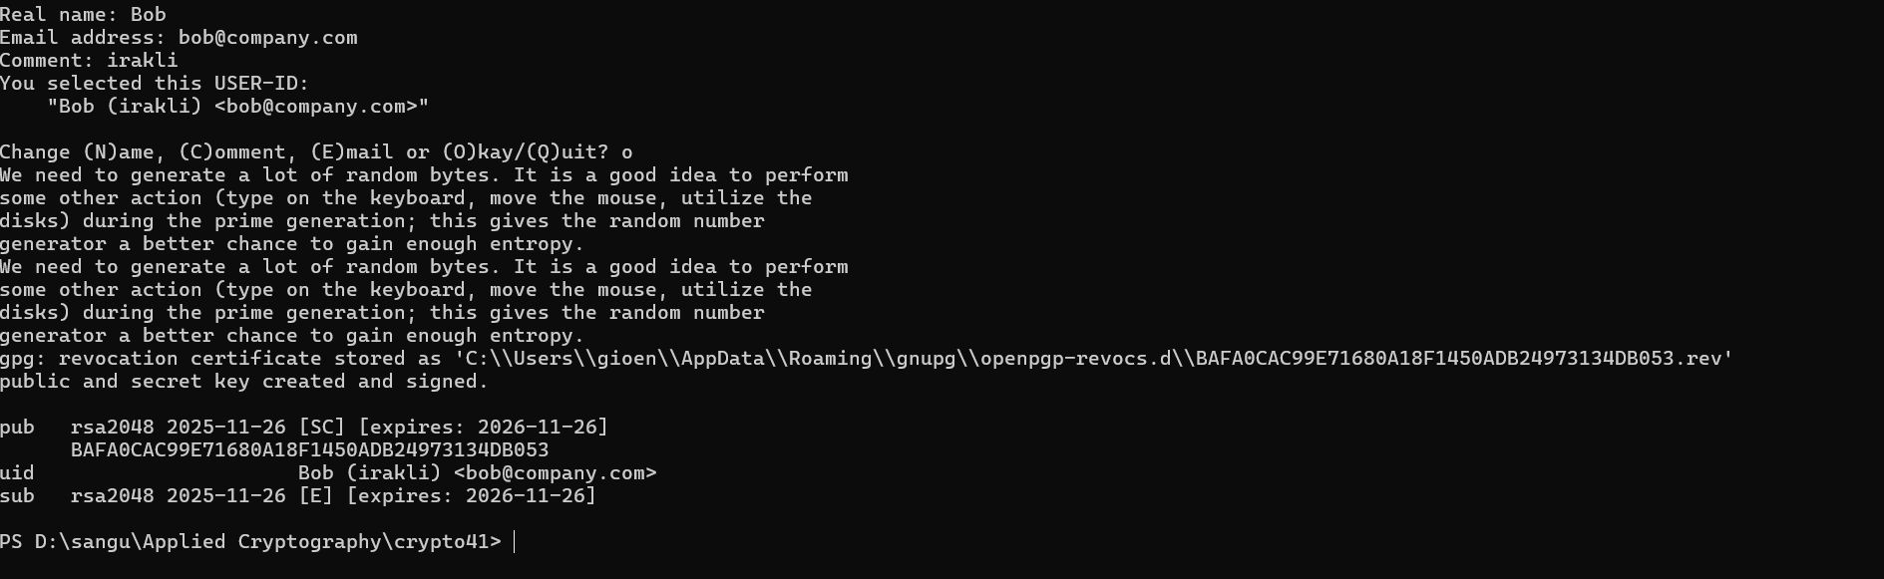

C. Exchange Public Keys (Prerequisite)
For the process to work, Alice must have Bob's public key, and Bob must have Alice's public key.
- Export Public Keys:



Import Public Keys:

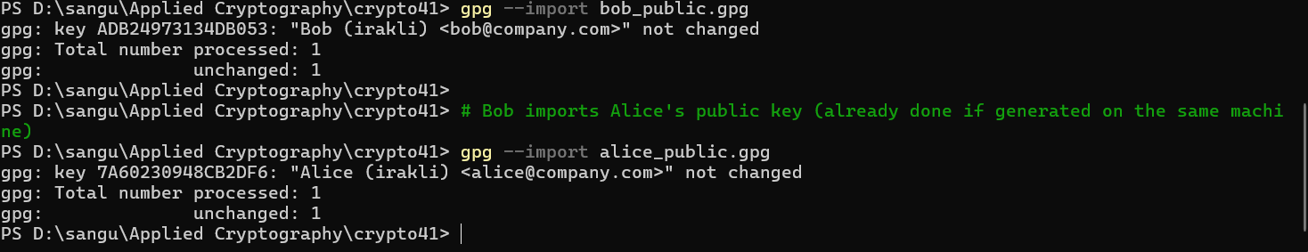

2. ✍️ Alice's Action: Sign and Encrypt the Message
Alice will create the message, then use Bob's public key to encrypt it and her own private key to sign it.

Create Original Message

Sign and Encrypt

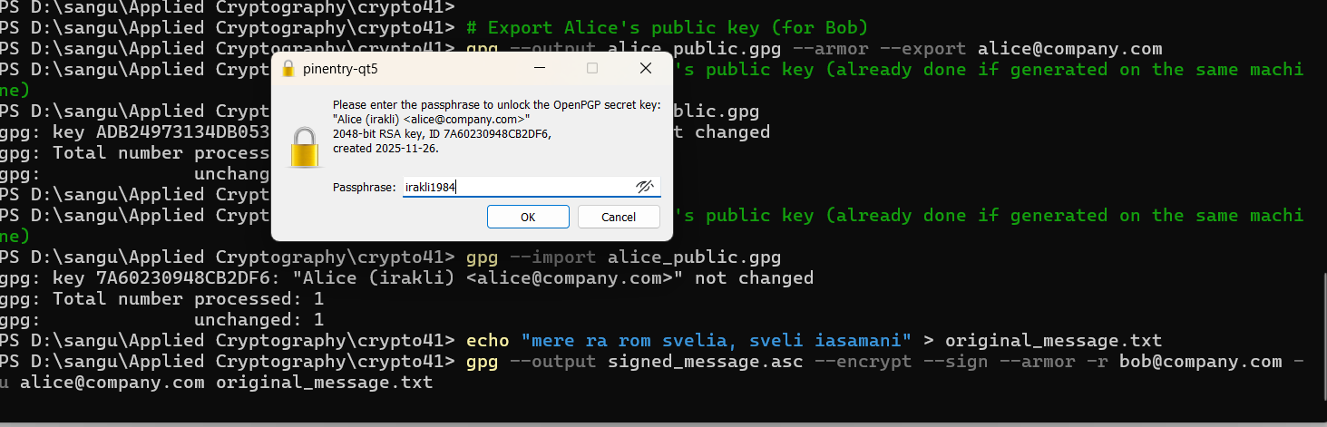

3. Bob's Action: Verify and Decrypt the Message
Bob receives the file. He first uses his private key to decrypt it, then uses Alice's public key to verify the signature.

Decrypt and Verify

